Internship supervisor’s report

For the course JKM141 Internship
Master Program in Media and Area Studies (MARS)
Institute of Communication Studies and Journalism,
Faculty of Social Sciences, Charles University
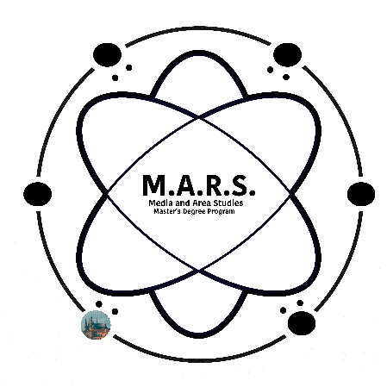

Research Team / Organisation (name, address, telephone, email):

Internship supervisor in Research Team / Organisation (name, phone, email):

Name of student (name, phone, email):

Actual period of internship (start date – end date):

Number of actual working hours in total:

Main tasks, activities and deliverables the student was engaged in during the internship and the degree of responsibility (i.e. the student undertook these tasks/produced these deliverables on her/his own, together with other interns, etc.):
Evaluation of student’s performance

1. Learning:

Excellent____ Very good____ Average ____ Unsatisfactory ____
[e.g., ability to develop skills or gain knowledge rapidly; ability to take advantage of opportunities to practice research skills]

2. Quality of work:

Excellent____ Very good____ Average ____ Unsatisfactory ____
[e.g., ability to take on and accomplish a variety of assignments; attendance to detail; self-reflexivity in relation to own work; accomplishment of tasks by high standards]

3. Attendance:

Excellent____ Very good____ Average ____ Unsatisfactory ____
[e.g., presence during the agreed times, attendance of scheduled/agreed meetings and activities]

4. Initiative:

Excellent____ Very good____ Average ____ Unsatisfactory ____
[e.g., ability to take initiatives related to planning and implementation of tasks and projects]

5. Professional attitude:

Excellent____ Very good____ Average ____ Unsatisfactory ____
[e.g., punctuality, ability to work in teams, attitude towards collaborators and supervisor]

Please, provide an account on the reasons of your evaluation.

Date
Signature by internship supervisor

